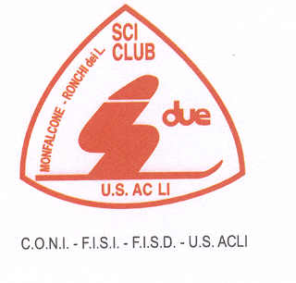


IPC ALPINE SKIING

IPCAS RACE
Trofeo “ European Cup 2015 Adriana Visintini”
GS / SL

PROGRAMMA

Tarvisio (Italy) 17-18 febbraio 2016

Organization: A.S.D. Sci club “DUE” –Ronchi dei Leg. (GO) (GO06)

PROGRAMMA

Monday  15.02.2016 | Until 16:00 | First Arrival | Hotel
Tuesday  16.02.2016 | 09.00 | Free ski | Tarvisio pista “Priesnig B”
Tuesday  16.02.2016 | 18:00 | 1st Team captain meeting | Tarvisio “Town Hall”
Wednesday  17.02.2016 | 09:30 | GS IPCAS race – 1^st run | Tarvisio pista “Priesnig B”
Wednesday  17.02.2016 | 12:30 | GS IPCAS race – 2^st run | Tarvisio pista “Priesnig B”
Wednesday  17.02.2016 | 14.00 | Prize giving ceremony | Finish Area
 | 18:00 | 2st Team captain meeting | Tarvisio “Town Hall”

Thursday  18.02.2016 | 09:30 | SL IPCAS race – 1^st run | Tarvisio pista “Priesnig B”
Thursday  18.02.2016 | 12:30 | SL IPCAS race – 1^st run | Tarvisio pista “Priesnig B”
Thursday  18.02.2016 | 14:00 | Prize giving ceremony | Finish area
Friday  19.02.2016 |  | Departure

